**Business Overview**

Bottled water is one commodity that is consumed in all parts of the world and of course those that are in the business of producing bottled water are known to generate sales year in year out if the business is well – managed. As a matter of fact, economic downturn hardly affects the consumption of bottled water simple because it is a commodity that is as important as the air we breathe in.

## Company Summary

Pure Flow, located in Ashdown Park, Harare, is a water bottling business that sells bulk water and bottled water units to end consumers and companies.

The business will be based out of Heartfelt International Ministries premises. It is forecasted that we will reach profitability by month 12, and we will earn modest profits by year three.

### Company Ownership

Pure Flow is a private company, founded and owned by **Heartfelt International Ministries**.

**Start-up Summary**

Pure Flow's start-up costs include the following items:

* Office furniture, including a desk, chair, and filing cabinets
* Computer system
* Stationery
* Brochures
* Legal fees
* Phone line, cell phone

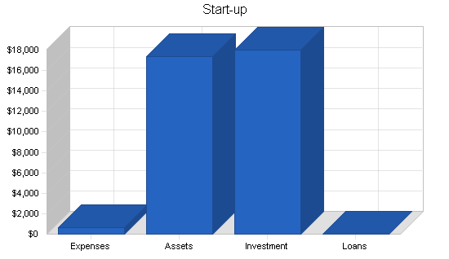

|  |  |
| --- | --- |
| Start-up Requirements | |
| Start-up Expenses |  |
| Legal | $200 |
| Stationery etc. | $200 |
| Brochures | $200 |
| Other | $0 |
| Total Start-up Expenses | $600 |
| Start-up Assets |  |
| Cash Required | $15,100 |
| Other Current Assets | $0 |
| Long-term Assets | $2,300 |
| Total Assets | $17,400 |
| Total Requirements | $18,000 |

|  |  |
| --- | --- |
| Start-up Funding | |
| Start-up Expenses to Fund | $600 |
| Start-up Assets to Fund | $17,400 |
| Total Funding Required | $18,000 |
| Assets |  |
| Non-cash Assets from Start-up | $2,300 |
| Cash Requirements from Start-up | $15,100 |
| Additional Cash Raised | $0 |
| Cash Balance on Starting Date | $15,100 |
| Total Assets | $17,400 |
| Liabilities and Capital |  |
| Liabilities |  |
| Current Borrowing | $0 |
| Long-term Liabilities | $0 |
| Accounts Payable (Outstanding Bills) | $0 |
| Other Current Liabilities (interest-free) | $0 |
| Total Liabilities | $0 |
| Capital |  |
| Planned Investment |  |
| Investor 1 | $18,000 |
| Investor 2 | $0 |
| Other | $0 |
| Additional Investment Requirement | $0 |
| Total Planned Investment | $18,000 |
| Loss at Start-up (Start-up Expenses) | ($600) |
| Total Capital | $17,400 |
| Total Capital and Liabilities | $17,400 |
| Total Funding | $18,000 |

## Products

Pure Flow will take advantage of its easy access to huge supply of clean borehole water to supply the market. Two different models will be sold:

1. **Bulk water**- structures will be made to facilitate sell of bulk water to companies and distributors of clean water
2. **Bottled Water**-

**Our Target Market**

When it comes to selling bottled water, there is indeed a wide range of available customers. In essence, our target market can’t be restricted to just a group of people, but all those who resides in our target market locations.

We have ideas of what our target market would be expecting from us. We will engage companies in wholesale distribution and engage the following groups;

* Hotels
* Restaurants and Canteens
* Event Planners, Parties and Corporate Functions
* Corporates
* Government Departments

**Our Competitive Advantage**

The bottled water production industry has become much more intensely competitive over the last decade. As a matter of fact, you have to be highly creative, customer centric and proactive if you must survive in this industry.

Pure Flow will launch a standard bottled water brand that will indeed become the preferred choice of customers.

Our employees will be well taken care of, and their welfare package will be among the best within our category (*startups bottled water companies*) in the bottled water industry, meaning that they will be more than willing to build the business with us and help deliver our set goals and achieve all our aims and objectives. We will also give good working conditions and commissions to freelance sales agents that we will recruit from time to time.

**SALES AND MARKETING STRATEGY**

In order to continue to be in business and grow, we will adopt the following sales and marketing approach to sell our products;

* Introduce our bottled water brand by sending introductory letters to residence, bottled water merchants and companies.
* Engage in road show in targeted communities from time to time to sell our products
* Advertise our products in local newspapers and publications
* Leverage on the internet to promote our bottled water brands
* Engage in direct marketing and sales
* Encourage the use of Word of mouth marketing (referrals)

**Our Pricing Strategy**

When it comes to pricing for products such as bottled watered, there are two sides to the coin. We are aware of the pricing trend in the bottled water production industry which is why we have decided to produce various sizes of bottled water.

In view of that, our prices will conform to what is obtainable in the industry but will ensure that within the first 6 to 12 months our products are sold a little bit below the average prices of various bottled water production brands. We will put in place business strategies that will help us run on low profits for a period of 6 months; to encourage people to buy into our bottled water brands.

**Payment Options**

Our payment policy is will be all inclusive because we are quite aware that different people prefer different payment options as it suits them. Here are the payment options that will be available to facilitate payments;

* Payment by cash
* Payment via Point of Sale (POS) Machine
* Payment via online bank transfer (online payment portal)
* Payment via Mobile money

In view of the above, we will chose a bank that will help us achieve our payment plans without any itches.